How to Use Socket.IO with Node.js and Express
Socket.IO is a JavaScript library that enables real-time, bidirectional communication between a client (browser or Angular application) and a Node.js server.
Unlike traditional HTTP requests, where the client sends a request and waits for a response, Socket.IO allows the server to send data to connected clients immediately, without waiting for them to request it.
Since you're working with the MEAN Stack (MongoDB, Express, Angular, Node.js), I'll explain it using Node.js + Express, with practical examples that you can also use in your course.

1. Why do we need Socket.IO?
Imagine you are developing an online shopping application.
Without Socket.IO:
- A user places an order.
- The admin dashboard doesn't know about the new order immediately.
- The admin must refresh the page or send another HTTP request to check for new orders.
With Socket.IO:
- A user places an order.
- The server emits a newOrder event.
- All connected admin dashboards receive the event immediately.
- The admin dashboard updates automatically.
Other use cases:
- Real-time chat applications.
- Live notifications.
- Online users tracking.
- Real-time dashboards.
- Multiplayer games.
- Live order tracking.
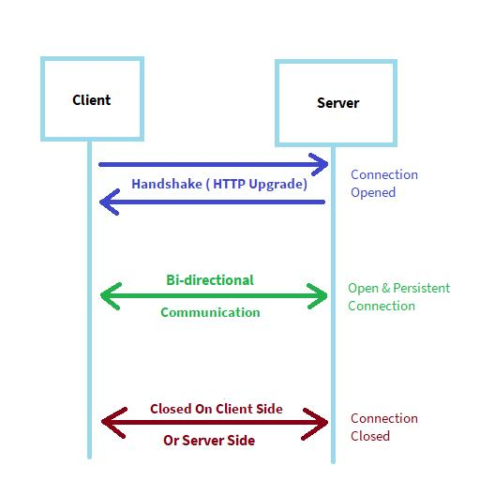

8

2. Install Socket.IO
Create a Node.js project or use your existing Express project.
Install the required packages:
npm install express socket.io

3. Create the Express Server
Create server.js.
The important point here is that Socket.IO needs an HTTP server, so we use Node.js's createServer() instead of directly calling app.listen().
server.js
const express = require('express');
const http = require('http');
const { Server } = require('socket.io');

const app = express();

// Create HTTP server
const server = http.createServer(app);

// Initialize Socket.IO
const io = new Server(server, {
cors: {
origin: '*',
methods: ['GET', 'POST']
}
});

// Express route
app.get('/', (req, res) => {
res.send('Express Server is Running!');
});

// Socket.IO connection
io.on('connection', (socket) => {

console.log('A user connected:', socket.id);

// Listen for a message from the client
socket.on('sendMessage', (message) => {

console.log('Message received:', message);

// Send message to all connected clients
io.emit('receiveMessage', message);

});

// Handle disconnection
socket.on('disconnect', () => {
console.log('User disconnected:', socket.id);
});

});

// Start server
server.listen(3000, () => {
console.log('Server running on port 3000');
});
Run the server:
node server.js

4. Understand the Socket.IO Server Methods
These are the most important methods you should understand.
Method | Description
io.on('connection') | Executes when a client connects
socket.on() | Listens for an event from a specific client
socket.emit() | Sends an event to a specific client
io.emit() | Sends an event to all connected clients
socket.broadcast.emit() | Sends an event to everyone except the sender
socket.join() | Adds a client to a room
io.to().emit() | Sends an event to clients in a specific room
socket.disconnect() | Disconnects a client

Important difference between emit methods
Suppose three users are connected: A, B, and C.
1. io.emit()
All clients
User A
User B
User C
Sends the message to A, B, and C.
2. socket.emit()
Specific client
User A
User B
User C
If called by the server's handler for A, only A receives the message.
3. socket.broadcast.emit()
Everyone except sender
User A
User B
User C
If called by A's socket, B and C receive the message, but A doesn't.

